Mens Hairstyle Recommendation Using Face Recognition

Group 17

1st Francesco Daniel Christian

Binus University

Tangerang, Indonesia

[francesco.christian@binus.ac.id](mailto:francesco.christian@binus.ac.id)

2nd William Herman Tioleu

Binus University

Tangerang, Indonesia

[william.tioleu@binus.ac.id](mailto:william.tioleu@binus.ac.id)

Aditya Kurniawan

Bina Nusantara University

West Jakarta, Indonesia

[adkurniawan@binus.edu](mailto:adkurniawan@binus.edu)

***Abstract—*** In daily life, everyone wants to always look their best. There are many things that affect a person's appearance starting from clothes, accessories, makeup, and so is the hair. Hair is a crown for many people and arguably very influential on appearance.

With this problem, we have an idea to make AI (Artificial Intelligence) to provide hairstyle recommendations to people. The purpose of making this research methodology is to provide recommendations for suitable hairstyles and also according to the shape of the face, the nature of the hair, and habits in maintaining hair in everyday life. In addition, we also want to test how sensitive AI (Artificial Intelligence) is to read the shape of the face and hair to a person's face. We also want to study how AI can learn using machine learning to understand the commands given so that it can achieve the purpose of the AI.

**Keywords— hairstyle recommendation, face recognition, artificial intelligence, machine learning**

1. **Introduction**

In this modern time when personal appearance is becoming one of the critical needs for self-expression and confidence, there has been an interest among vast numbers of people to look better or improve their visual appeal. Among the varied factors of an individual's appearance, hair is one of the most recognized features; it is like a canvas on which imagination and self-expression can be let loose. Our hairstyles reflect personality, social influence, and lifestyle in the casual, sleek bob, wavy curls, or bold pixie cut.

Research has indeed confirmed that personal appearance has an impressive impact on self-confidence and social interaction. The American Psychological Association has conducted a research study in which 79% of the subjects believe that their look helps to build self-esteem, and 64% report that looking good makes them feel confident. Also, another study published in the journal *Psychology of Well-Being* showed that 85% of respondents, when satisfied with their hairstyle, felt more confident and happier. These statistics highlight that personal appearance is a part of one's everyday life and is also directly related to a person's sense of identity and level of confidence.

Most traditional ways of offering hairstyle recommendations, like visiting a professional hair stylist or going through generalized charts of face shapes, are not personalized and time-consuming. These methods are often judgmental and may, in one way or the other, dismiss people's preferences, variety of texture in hair, and variations in lifestyle. Moreover, conventional face shape charts tend to oversimplify complex facial features into a few categories, leading to generic recommendations that do not work for everyone's unique attributes. This causes the resulting hairstyle to be unsatisfactory in that it does not, therefore, necessarily go best with the particular person's facial structure or personal style.

Recognizing that hair helps an individual achieve their personality, this paper now shows the most up-to-date progress in the fact that artificial intelligence methods and technologies are combined with face recognition to provide custom-made recommendations for hairstyles. To propose suggestions, in this paper, facial features are factored in with a person's hair texture, combined with personal choices. This study mainly aims to develop a potential AI model for better and improved suggestions for haircuts based on face shapes and hair type. We believe the training dataset with photographs of faces and haircuts makes the model learn some patterns and suggests more decent options.

**Research Objectives:**

1. **Suggested Appropriate Hair Design:** Our AI system suggests hair designs based on face cut, hair type, and the day's support plan that will go with that to complement the highlights of a person's look. Whether you have a heart-shaped face, an oval contour, or a square jawline, our model will recommend an original design.
2. **Analyze Sensitivity of AI:** We propose a probe for assessing how sensitively AI may react to small nuances in facial shape and hair design. Can it differentiate between the best hairdo for a round confrontation and an exact one? To what level can it adapt to the different types of hair textures, ranging from delicate and straight to thick and wavy?

In following these goals, we study machine learning. Our approach involves collecting heterogeneous data about face images with various haircuts. The AI model will then be developed based on this data, and it will be used for pattern recognition and personalized recommendations for the haircut. Work in parallel with the enhancement of sensitivity regarding subtle facial features and diverse textures of hair should be done so that the offered inferences are accurate and correspond to individual needs. The refinement in the system further can be tuned with the user feedback more towards the response and effectiveness of the system.

In this paper, we step through the complexity of our techniques, observe the effect of hair-related recommendations on self-perception, and describe the fascinating interplay between invention and aesthetics. We endeavor to apply the power of AI to revolutionize how people go about choosing their hairstyles, enabling them to enjoy greater levels of confidence and self-expression.

1. **Literature Review**

Face shape classification is used in a variety of applications:

1. **Feature-based face recognition:**

As observed by Y. Zhang and Prakash (2008), similarly to previous research, all the studies suggested the process and assumed frontal face direction and head extraction in advance. The approach used in feature-based face recognition for detecting face shapes to tell a hairstyle is constrained to two-dimensional information; therefore, it does not consider the dynamic variability of face shape. Consequently, it is unsuitable for 3D data without the identification of the frontal orientation of the face (Institute of Electrical and Electronics Engineers, 2008).

1. **Support Vector Machine:**

Kamble, Y. M., and Kulkarni, R. B. (2019) stated that due to the feature-based system, a non-contact classification technique for face shapes can be proposed with the technology Support Vector Machine (SVM). This three-step algorithm includes head segmentation, face plane identification, and face form classification. Since the whole 3D body data are captured and offered as input to the system, the frontal side is defined using an Eigenvector. The head is segmented in a 3D space with the help of head segmentation that fuses the information coming from the Chin-Neck Junction, Ellipsoid Fitting Technique, and Mahalanobis Distance. When the face shape projected appears in the plane of the face, the facial shape is determined. The principal axes of the ellipsoid determine the face plane lying across the head. In the third step, face shapes on the face plane are classified into four classes: ellipse, long, round, and square face shape.

Accuracy rate is 73.68%. Significant points for classification are located in 91 positions around the face [2].(Kamble & Kulkarni, 2024)

1. **3D face data:**

K. Wilamowska et al. (2009) suggested differentiation between 22Q11.2 syndrome patients and the average public with facial data. The process of calculation uses 3D face data to calculate the difference of facial features. Two sets of data make use of shape-based morphology. The detection methodology uses a 3D photo, a 2.5D depth image, and a curved line of the face. The classification is done using the feature vectors in conjunction with Principle Components Analysis. The accuracy percentage was between 74% and 76% [1].

1. **SVM with expert knowledge:**

Wisuwat Sunhem et al. (2016) proposed a hairstyle recommendation system for women based on expert knowledge and a face shape classification scheme. Using Support Vector Machine methods, the system divided the user's facial shape into five groups appropriate for hairdo recommendations. The hairdo restrictions were based on ideas from beauty professionals. The approach is based on the fine-grained similarity of facial shapes. However, the contour of the human face varies with time. For example, being obese owing to increased work pressure might alter the form of a person's face. As a result, our goal is to create and execute a coarse-grain similarity of face shape for hairstyle recommendations. Even their work was observed, confirmed, and granted by the National Natural Science Foundation of China [4].(Pasupa et al., 2019)

1. **SVM-RBF method:**

Pasupa, K., Sunhem, W., & Loo, C. K. (2019) provides an option to use the SVM-RBF method which approaches to improve the face shape classification process using 3 descriptors, namely DG, DV, and DF. The system provided will race with the guidance of hair experts in identifying suitable hairstyles for face shapes which will produce accurate results. They also provide related work on facial recognition-assisted recommendation systems that aim to help the system consider preferences and match hairstyles to the user's face, and with the help of expert guidance that allows the system to broadly recognize faces and provide hairstyle recommendations that match the user's face. They outlined the methodology, dataset collection, feature extraction and evaluation for the hairstyle recommendation system [3].(Pasupa et al., 2019)

1. **Methodology**
2. *Algorithm Method Comparison of  two papers*

For our research, we compared different methods of algorithms used in two research papers made by **Kamble, Y. M., and Kulkarni, R. B. (2019)** and **K. Wilamowska et al. (2009).**

Wilamowska's research uses Classification data where they use 3D face photos. By using face recognition, the system can identify the lines on the target face. The classification is carried out using feature vectors in conjunction with Principal Components Analysis. There was 76% accuracy produced by the study.(Atmosukarto et al., 2010)

The research reference written by Kamble uses the SVM (Support Vector Machine) algorithm. This algorithm unfolds in three phases: partitioning of the head, identification of the facial plane, and categorization of facial form. Initially, the entire 3D body data is collected and fed into the system, with the frontal aspect being determined by an Eigenvector. The 3D head is isolated using a head partitioning method that merges the Chin-Neck Junction, Ellipsoid Fitting Technique, and Mahalanobis Distance. Subsequently, the facial contour becomes visible when projected onto a plane. The major axes of the ellipsoid establish the facial plane, which extends along the head. In the final phase, facial shapes on the facial plane are classified into four categories: elliptical, elongated, circular, and quadrangular facial shape. There was 73.68% accuracy produced by the study.(Kamble & Kulkarni, 2024)

1. *Dataset*

Datasets are important for training the hairstyle recommendation system in the way we intended. There are several obstacles that we experienced in searching for this dataset, such as it is difficult to learn such as if you want to use a hairstyle what must be fulfilled to match the hairstyle, whether from the shape of the face, the nature of the hair, the location of the eyes and nose, and many other aspects. In this research, of course, it requires a lot of datasets to get high accuracy. We get the dataset used in this research by searching for data.

sources online by classifying data images according to face shape, hair shape, and hair nature. We will input these data into the machine learning code to train the system to determine hairstyle recommendations properly. Here are some of the data sets we got from our online dataset search:

1. *Algorithm Method*

We used three algorithms to perform testing in our code, namely :

1. Face detection using MTCNN

MTCNN (Multi-Task Cascade Convolutional Networks) is used to detect faces in images. MTCNN consists of three different authentication networks: P-Net, R-Net, and O-Net.

P-Net : P-Net provides offers connecting the box to the switch.

R-Net : R-Net processes requests from P-Net.

O-Net : O-Net re-filters requests received by R-Net and provides a final box showing eyes, nose, and mouth.

Basic formula:

𝑦 = 𝑓 (𝑊 ∗ 𝑥 + 𝑏)

1. Feature extraction using FaceNet

FaceNet is used to extract facial features. FaceNet is a deep learning model that provides graphs used to compare and recognize faces. An embedding is a low-level plane vector (e.g. 128-dimensional). This process involves forward passing through neural networks trained to produce output from facial images. Embedding is done using a fully integrated layer.

Basic formula:  
  
 a^[l] = f(W^[k]a^[k−1]+b^[k])

1. Classification using K-Nearest Neighbors (KNN)

After removing the face, KNN is used to classify the hair. KNN is a model-based machine learning algorithm used for classification and regression. In this context, KNN is used for classification.

KNN step:

- Calculate distance: Calculate the distance between the new sample and all samples in the training data.

- Select K nearest neighbors: Select the k nearest neighbors according to the calculated distance.

- Multiplexing: Create a class based on the number of k nearest neighbors

Basic formula 

1. **Result**

From the results of the code we made, In this research work, we have designed a system for hairstyle recommendations based on AI techniques and machine learning algorithms developed through the analysis of face shapes and hair types.

The MTCNN algorithm has been used to detect the face from images and to detect face key points: eyes, nose, and mouth. FaceNet extracts fine-grained features of the face and creates embeddings, which are low-dimensional vector representations for each face.

We applied the KNN (K-Nearest Neighbors) algorithm to classify facial shapes, lengths of hair, and hairstyles based on the features. The classifiers are made ready within our dataset, containing 80% for training and the remaining 20% for testing.

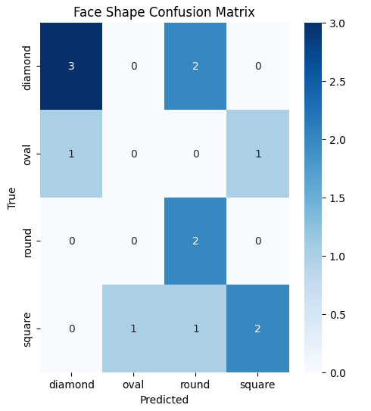

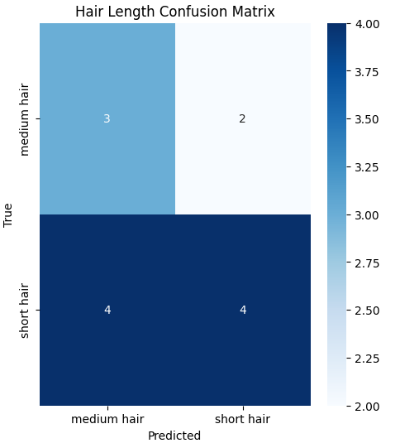

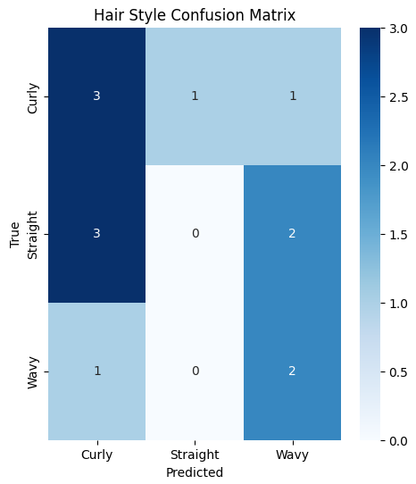

The performance of our model was evaluated using classification reports and confusion matrices for each category (face shape, hair length, and hair style). The results showed that our model achieved:

**Face Shape Accuracy: 53.85%**

**Hair Length Accuracy: 53.85%**

**Hair Style Accuracy: 38.46%**

in classifying the different attributes.

With these rates, it indicates that our model can classify only up to some extent of distinctly different attributes. There is much scope for improvement because the initial size and diversity of our dataset constrains the current accuracy rates. Further training on more extensive and more diverse data would let us give more accurate and precise recommendations. With the addition of our dataset and further development of the algorithms, we would ensure the improvement in the model performance.

Input :

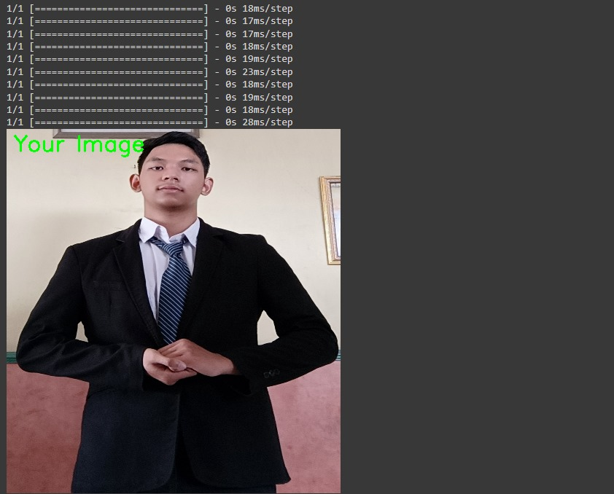

Output :

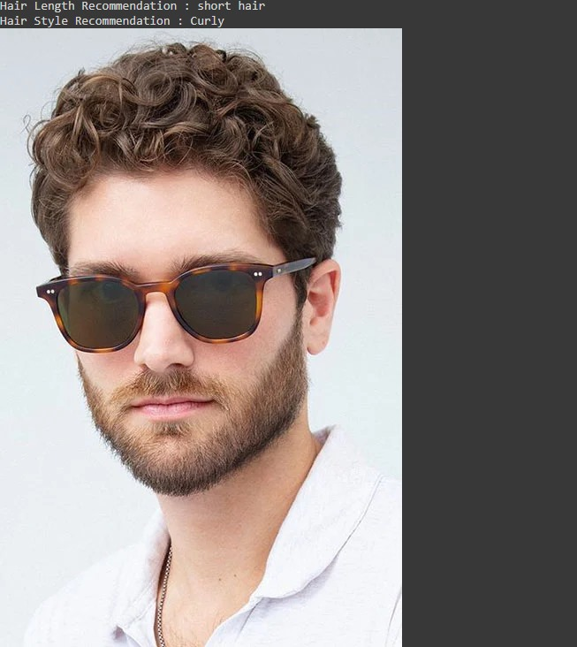

Input :

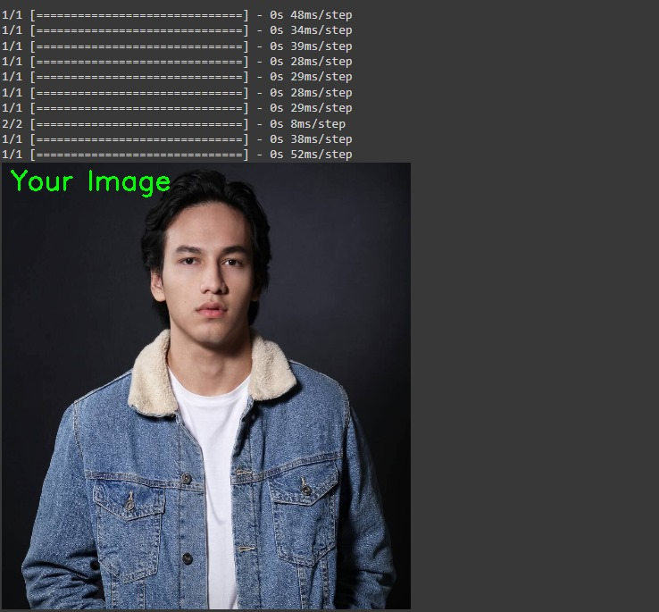

Output :

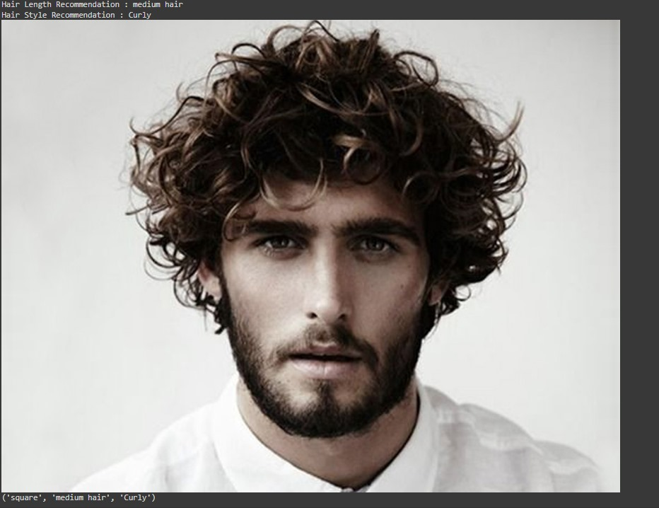

As shown through the inputs and outputs of the code, when an image is uploaded, it appears together with the title with visual representations of suggested hairstyle ideas. This system picks some random photos from the predicted categories and displays visual recommendations as a means of suggestions for users.

1. **Evaluation**

Our study looks at using facial recognition to help suggest good hairstyles. It tries to match preferences and face shape to recommend styles. Utilizing expert guidance to help detect faces and make fitting suggestions. We compared methods like algorithms and data processing that are aimed to give hairstyle ideas based on face shape and hair type. By using SVM, achieved 76% accuracy for face shape classification and hairstyle recommendations. The goal is personalized suggestions looking at individual features. It explores if AI can detect subtle traits to suggest hairstyles well. The other system uses techniques like Principle Components Analysis and Support Vector Machine. It classifies faceshapes and recommends hairdos based on this.

Our research stresses the significance of personal looks and self-expression via hairstyles. We utilize AI and facial recognition to suggest individualized hairstyles. Additionally, we aim to establish a coarse-grained similarity of face shapes for precise hairstyle recommendations.

In summary, our research adopted a thorough strategy, leveraging AI and facial recognition tech for personalized hairstyle suggestions.

Overall, the evaluation of the research indicates a comprehensive approach to utilizing AI and facial recognition technology for personalized hairstyle recommendations

1. **Conclusion**

Using AI and facial recognition technology, we can suggest personalized hairstyles based on people’s traits like face shape and hair type. The results showed that the AI model could identify key facial points successfully, then offer tailored recommendations. However, further training of the AI model along with a bigger dataset is necessary to improve recommendation accuracy. In short, we emphasized the importance of machine learning for training the AI model, enhancing performance while providing personalized hairstyle suggestions.

**References**

[1] Atmosukarto, K. Wilamowska, C. Heike, and L.G. Shapiro, "3D object classification using salient point patterns with application to craniofacial research," Pattern Recognition, vol. 43, no. 4, pp. 1502-1517, 2010, doi: 10.1016/j.patcog.2009.09.021.

[2] Y.M. Kamble and R.B. Kulkarni, "Recommendation System for Hairstyle Based on Face Recognition Using AI and Machine Learning," IGI Global, vol. 1, no. 1, pp. 1-10, 2019, doi: 10.4018/IJSI.309960.[*Https://Services.igi-Global.com/Resolvedoi/Resolve.aspx?Doi=10.4018/IJSI.309960*](https://services.igi-global.com/Resolvedoi/Resolve.aspx?Doi=10.4018/IJSI.309960). <https://www.igi-global.com/gateway/article/full-text-html/309960>

[3] K. Pasupa, W. Sunhem, and C.K. Loo, "A hybrid approach to building face shape classifier for hairstyle recommender system," Expert Systems with Applications, vol. 120, pp. 14-32, 2018, doi: 10.1016/j.eswa.2018.11.011. <https://doi.org/10.1016/j.eswa.2018.11.011>

[4] W. Sunhem and K. Pasupa, "An approach to face shape classification for hairstyle recommendation," in 2016 Eighth International Conference on Advanced Computational Intelligence (ICACI), 2016, pp. 1-5, <https://doi.org/10.1109/icaci.2016.7449857>

[5] Y. Zhang and E.C. Prakash, "An example-based anthropometric model for face shape synthesis," IEEE Int. Conf. On Multimedia and Expo, pp. 1573-1576, 2008, doi: 10.1109/icme.2008.4607749. <https://doi.org/10.1109/icme.2008.4607749>

[6] Man For Himself. (n.d.). *Men’s Hairstyles Archive*. Man for Himself. <https://manforhimself.com/mens-hairstyles/?fwp_hairstyle_hair_type_category=mens-normal-type-hairstyles%2Cmens-thick-hair-hairstyles%2Cmens-thin-hairstyles&fwp_hairstyle_hair_length_category=mens-medium-length-hairstyles>